Standardized Software Development Phases Document
Saniya 67168510, Abhijith 32777150, Anibal 27857066, Beatrice 38548252
Introduction
The process of software development is multifaceted, requiring careful planning, execution, and evaluation. To ensure consistency and quality, a standardized approach is essential. This document outlines the 8-phases model (Verify - Design - Validate) as a structured method for managing software development projects. Integrated with Indexed Development Phases (LCT), this approach ensures that every stage is systematically tracked and documented. The document also highlights the procedures and formats used in each phase, along with documentation and source code management techniques to maintain project integrity.

Development Model: 8-Phases Model
The 8-phases model divides the software development lifecycle into distinct stages, enabling developers to follow a clear and logical process. Each phase includes specific steps, procedures, and documentation formats.
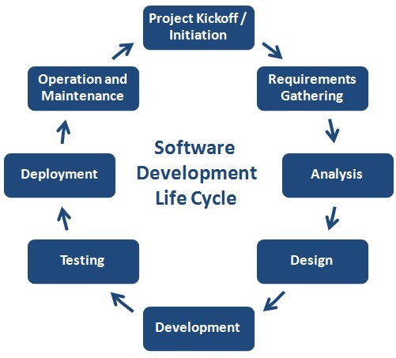

Phase 1: Project Kickoff / Initiation
  - Steps Involved:
    - Define project objectives and scope to establish clear goals.
    - Identify stakeholders and assign roles to ensure accountability.
    - Prepare a preliminary project plan, including timelines and resource allocation.
  - Procedures and Format:
    - Use a project charter document to formalize objectives and responsibilities.
    - Conduct stakeholder meetings to finalize the project’s vision and goals.

Phase 2: Requirement Gathering and Analysis
  - Steps Involved:
    - Gather functional requirements (e.g., specific features) and non-functional requirements (e.g., performance, security).
    - Create use cases and user stories to represent user interactions.
    - Validate requirements with stakeholders to ensure alignment.
  - Procedures and Format:
    - Document requirements in a Software Requirements Specification (SRS).
    - Use visual aids such as flowcharts, mockups, or wireframes to clarify requirements.
    - Employ tools like Jira or Trello to track requirement changes and updates.
Phase 3: System Architecture and Design
  - Steps Involved:
    - Develop architectural diagrams and system layouts to define the structure.
    - Create detailed data models, interface designs, and workflow diagrams.
    - Prepare design documentation for reference during implementation.
  - Procedures and Format:
    - Use a Design Specification Document (DSD) to record system architecture and design decisions.
    - Conduct design reviews with cross-functional teams to identify potential issues early.
Phase 4: Development and Implementation
  - Steps Involved:
    - Write modular code and test individual components.
    - Integrate components incrementally to identify integration issues early.
    - Conduct peer code reviews to ensure adherence to coding standards.
  - Procedures and Format:
    - Follow coding standards and guidelines for consistency.
    - Use version control systems (e.g., Git) to manage source code.
    - Incorporate continuous integration/continuous deployment (CI/CD) pipelines for efficiency.

Phase 5: Verification and Testing
  - Steps Involved:
    - Perform unit testing on individual modules to validate their functionality.
    - Conduct integration testing to ensure components work together seamlessly.
    - Document testing outcomes to track progress and identify issues.
  - Procedures and Format:
    - Use a Testing Plan document to outline testing objectives and procedures.
    - Record results in a Test Summary Report (TSR) for analysis.
Phase 6: Validation and User Acceptance Testing
  - Steps Involved:
    - Conduct system testing and user acceptance testing (UAT) to ensure the product meets requirements.
    - Validate the software against the initial objectives and user expectations.
    - Prepare a comprehensive validation report.
  - Procedures and Format:
    - Use UAT scripts to guide the testing process.
    - Document findings in a Validation Report (VR) to highlight discrepancies and resolutions.
Phase 7: Deployment
  - Steps Involved:
    - Prepare deployment scripts and environments to ensure a smooth transition to production.
    - Conduct pre-launch checks to verify system readiness.
    - Deploy the system to the production environment.
  - Procedures and Format:
    - Use deployment checklists to cover all critical steps.
    - Maintain logs of deployment activities for future reference.
Phase 8: Maintenance and Continuous Improvement
  - Steps Involved:
    - Monitor system performance to identify potential issues.
    - Fix bugs and apply updates as needed.
    - Document all maintenance activities for transparency.
  - Procedures and Format:
    - Use a Maintenance Log to track updates and fixes.
    - Conduct regular performance reviews to ensure continued system reliability.

Source Code Management Practices
- Branching Strategies
  - Create feature-specific branches for isolated development.
  - Use release branches for preparing production-ready code while enabling ongoing development.
- Commit Standards
  - Follow a commit message convention, such as <type>(<scope>): <description> (e.g., fix(cart): resolve issue with item quantity update).
- Documentation Tools
  - Phase Record Document (PRD): Tracks milestone completion and team member contributions.
  - Change Log Document (CLD): Logs semantic versioning (e.g., 1.0.1) for updates.

Summary
The 8-phases model, integrated with Indexed Development Phases (LCT), offers a structured approach to managing software development projects from start to finish. This model breaks the development process into distinct phases, such as Project Kickoff, Requirement Analysis, System Design, Implementation, Verification, Validation, Deployment, and Maintenance. Each phase is designed with specific steps, procedures, and documentation practices to ensure that the project progresses systematically. With tools like Software Requirements Specifications (SRS), Design Specification Documents (DSD), and Testing Plans, the model ensures comprehensive tracking of project milestones, maintaining clarity and focus throughout the development lifecycle.
In addition to the structured phases, robust source code management practices further enhance the development process. The use of version control systems, branching strategies, and standardized commit messages helps maintain code integrity and facilitates collaboration among team members. Continuous integration pipelines and deployment checklists ensure that the development and deployment processes are both efficient and reliable. By adopting this standardized approach, software teams can address challenges proactively, improve project transparency, and consistently deliver high-quality results.

